Game Concept & Design Document
Version 1

Dauntlet

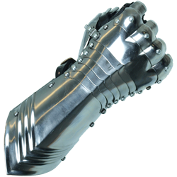

Crystal Methods
Braun, Eric
Hart, Adam
Keller, Colton
Leatherman, Garrett
Losinski, Tyler

Submission: Monday, February 23

Introduction

Dauntlet is a top down rogue-like comedy thriller game. There is free movement, enemies, and progression in Dauntlet.

Game Atmosphere

Dauntlet is a colorful and upbeat game. There are some sound effects for enemies and the player. There are two types of characters in Dauntlet, player and enemies. Both characters have the ability to attack and take damage. Dauntlet will have multiple rooms that you may progress through by defeating enemies.

